PHI THETA KAPPA
HONOR SOCIETY

ALPHA NU SIGMA CHAPTER
Horry-Georgetown Technical College

CHAPTER MEETING
TUESDAY 10/17/23
START: 6:07pm
END: 7:18pm
ADVISORS: BETH, LEILA, PAULETTE
OFFICERS: SHELL, TANYA, TRELLA, CARMEN
OTHER ATTENDANCE: 9
ZOOM: 1

NEW MEMBER ORIENTATION
- REVIEW OF SLIDES
QUESTIONS AND ANSWERS
- Meeting Times
  - One meeting in November and December.
  - Back to regular scheduling in January > every third Tuesday.
  - Look for email invitations.
  - We are child friendly.
- Worth it to participate even if you graduate in 6 months.
- What kind of community service?
  - We are always looking for ideas and will do a vote.
  - Birds of Prey
  - Help for Kids
  - Beach Sweep
  - Backpack Buddies
  - Food Pantry Donations
- 5 Star Chapter

CHAPTER MEETING
- SERVICE
  - Birds of Prey 11/4
    - See Tanya for Sign up Link
      - 1 signup
    - Can bring family/friends over 16 years old.
  - Period Project 11/3
    - You may pack, donate, or pack and donate.
    - 9am 11/3 on Conway Campus, Bldg 300, Room 110
    - Lauren.Davis@hgtc.edu > RSVP here by 10/23.
    - If you would like to donate, needs are: Ultra Thin Pads sizes 1-3, Overnight Pads, size 4, Tampons regular size, Hygiene Wipes (individually wrapped).
    - Drop off at Lauren Davis’s office (1100C, 233).
  - Waccamaw Youth Center Collection (new)
    - There are currently 231 children in Horry and Georgetown counties in Foster Care, and 3,622 children in Foster Care statewide. A third of the children in Foster Care in our area are between the ages of 13-17 years old. The Waccamaw Youth Center is a local, private, non-profit agency committed to providing comprehensive residential services for boys aged 12-21 in DSS’s care. The boys in their care remain in the community (go to local schools and attend outings at various places) while receiving the long-term therapeutic services they need. The staff at the Center provides continuous opportunities for the youth to develop positive self-esteem, academic/vocational abilities, and the life skills necessary to become productive, contributing members of society.
    - List of items to donate or cash donations.
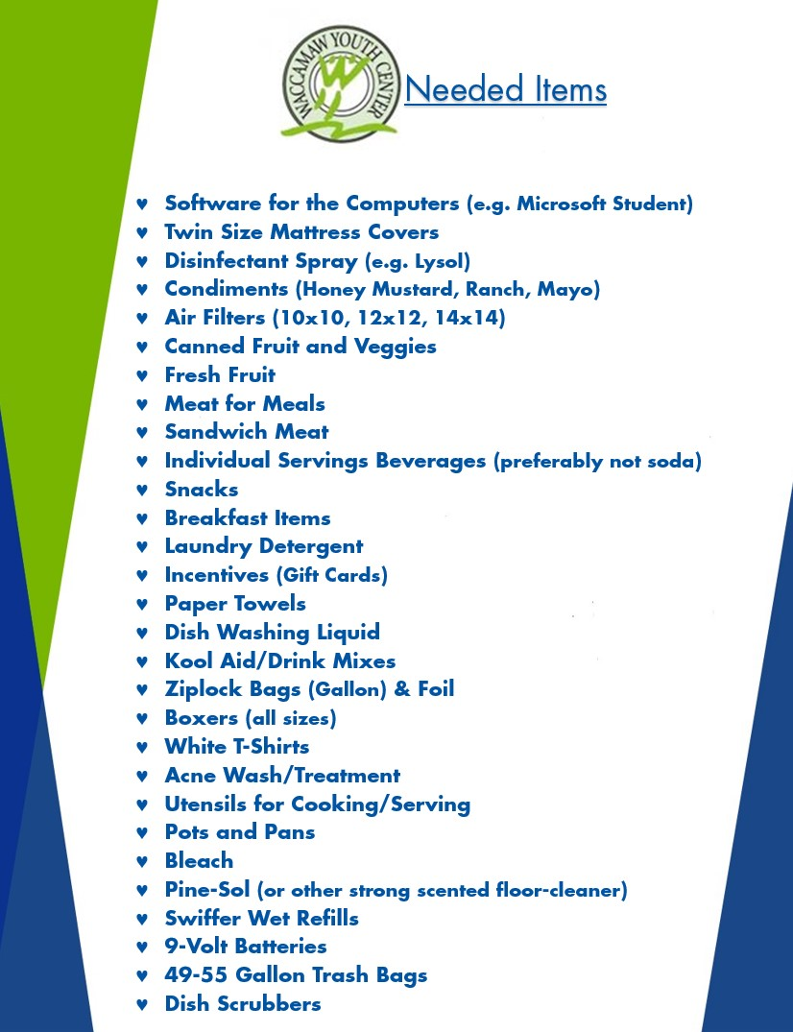
    - Do we want to participate? Optional.
      - Vote: Majority Yes
      - If yes, we can have people bring stuff at next meeting?
    - Bring to induction ceremony? 11/13
      - Vote: Majority Yes
      - Please ask your friends and family that will be watching you get inducted to bring items for this to the induction ceremony.
        - Optional
- NEXT CHAPTER MEETING 11/28
  - Bring donations for Waccamaw Youth
  - Invitation will be sent via email
- INDUCTION 11/13
  - Advisor will send details.
  - Members requested to arrive at 6pm for rehearsal.
  - Ceremony starts at 7pm.
  - Wear black and white.
- REGIONAL PROJECT
  - Hidden Conditions
  - Suicide Awareness Board displays in library was created by PTK.
  - 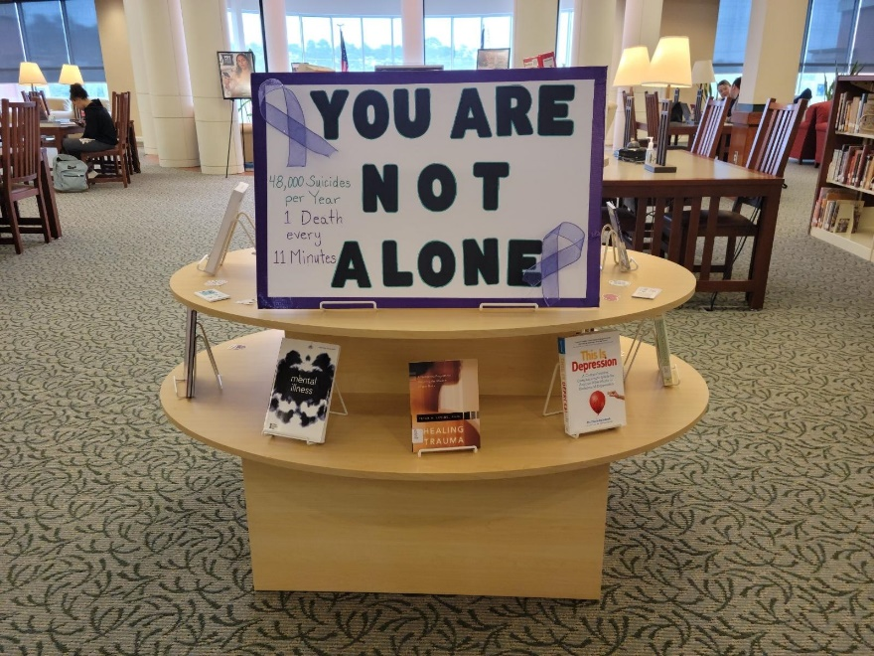
  - Please let your family know there is help available (suicide hotline)
- SCRAPBOOK
  - This year’s theme: Magic of Play
  - We welcome your help in putting it together.
- ASK AN OFFICER
  - If you have any questions at all that you think we can answer, please don’t hesitate.
  - Introduction to Advisors too.
- HIA – Surfside Senior Center 10/20 at 8:30am
  - Approximately 1 hour.
  - Packed the goody bags for the Surfside Senior Center.
    - Puzzle book, socks, hand sanitizer, lip balm
  - Wrote out charade cards for event.
  - Tallest tower competition with spaghetti and marshmallows.
  - Random object box.
    - If you are attending, please bring a random item for the box
  - Electronic Bingo Board.
  - Nintendo Switch.
  - Karaoke Machine.
  - Play with the seniors and ask qualitative questions.
  - Write up will follow.
  - There are approximately 3 people from meeting that have said they will go to event and help.

