HiA Hallmark Award Entry–2600 words total (328 in questions)

1. Provide a brief abstract or summary of your Honors in Action Project including the following components: academic research into and analysis of sources related to the Honors Study Topic, action that addresses a need in your community that was discovered through your research and analysis into the Society's current Honors Study Topic, and the impact of your project. (NOTE: Recommended word count for the abstract is no more than 300 words.)

Alpha Nu Sigma officers began by reviewing the Honors Study Guide, The Power of Stories, during officer training. To improve our academic research skills, we attended a research workshop conducted by our college’s research librarian. Initial research led us to Theme 5, Representation Through Stories, with a focus on cultural appropriation and misrepresentation of marginalized groups. The Jackson (2021) study helped us understand cultural appropriation, and the article from the American Bar Association (2024) explained the struggle of Native American groups to protect their Indigenous property. During an officer meeting, we learned of two local marginalized groups, the Gullah/Geechee Nation and Waccamaw Indian People, and we wanted to learn more about them. We invited our college’s anthropology professor to an officer meeting to give a presentation on each group. She provided insight on the struggles of the Gullah/Geechee Nation and the Waccamaw Indian People to protect their land and preserve their culture, and she became an important collaborator. Members decided to focus on the Waccamaw Indian People, who were seeking federal recognition to reclaim their ancestral remains and artifacts. We conducted an online survey to assess student’s awareness of the Waccamaw Indian People, and found over half of respondents were unfamiliar with them, and over 90% had not attended a PauWau. Our action promoted awareness of the Waccamaw Indian People’s annual PauWau through a tri-fold display at our college’s library during Native American Heritage Month. It educated the college about the PauWau and the importance of cultural respect, emphasizing cultural appropriation. Additionally, we volunteered for two days at the PauWau and set up vendor tents, bleachers, and hay bales. When the PauWau ended, we cleaned the grounds and stowed equipment for next year. Our project raised awareness, encouraged attending the PauWau, and made us understand the need to respect and protect cultural identities to ensure their stories are properly told.

1. Theme 5
2. **\*** Summarize your research objectives. In other words, what did your chapter set out to accomplish in terms of its research? (See Research Objectives Rubric in the [Honors in Action Project Rubrics](https://connect.ptk.org/web_files/advisor/static_files/staticPagesImages/2025_honors_in_action_project_rubrics_FINAL.pdf) for more detail.)

We reviewed Honors Program Guide themes during officer training and identified areas of interest. At our next meeting, we shared preliminary research on the themes we found most interesting. We developed the following research objectives:

1) Read the Honors Program Guide and choose a theme

2) Attend an academic research workshop conducted by our college’s research librarian

3) Complete Research Edge

4) Develop a research question

5) Review at least 20 academic sources related to our selected theme, including global perspectives

6) Select 5 academic sources

1. Describe your credible research into the Honors Study Topic, your research questions(s), your analysis of your research findings, and your research conclusions.

We attended a research workshop conducted by the research librarian at Horry-Georgetown Technical College (HGTC). Three committee members completed Research Edge. During officer training, we reviewed the Honors Program Guide and selected several themes for further exploration. At the next officer meeting, we discussed our findings and decided to pursue Theme 5, Representation Through Stories. We focused on how cultures are often misrepresented due to cultural appropriation. This led us to our research question: How does cultural appropriation contribute to lost stories or misrepresentation?

The Jackson (2021) study defined cultural appropriation as when dominant group members indirectly take cultural forms from a subordinate group, upsetting subordinate group members. A recent example from the news (2024) is actor Simu Liu taking offense at two entrepreneurs on a Canadian television show pitching their version of Boba tea without acknowledging its history and importance in Asian culture. Murphy (2023) explained how symbols and the written history of Native Americans were colonized and misappropriated, altering their representation through stories. Native Americans were presented as “cannibals,” when the true “cultural cannibals” were settlers who appropriated cultural items without consequence. Taylor (2015) argued Native American mascots represent a distorted version of Native American identity, spreading stereotypes and reinforcing the power imbalances rooted in America’s historical colonization. Recently, several professional sports teams have changed their names, such as the Washington Redskins becoming the Commanders. The article by Naholowa’a (2024) from the National Bar Association discussed the challenges of protecting Indigenous cultures through intellectual property laws. Despite international efforts, such as the United Nations’ Declaration on the Rights of Indigenous Peoples (UNDRIP), there has been limited progress in the United States to protect Indigenous cultural property. The study highlighted the importance of having Native voices in legal discussions and the need for better protection for Indigenous knowledge and traditions. He (2024) addressed cultural appropriation in the recent adaptation of Mulan, Disney’s 2020 film. He criticized how the film substitutes authentic Chinese elements with exoticized interpretations aimed at appealing to Western audiences, leading to disappointment among Chinese viewers who felt their culture had been misrepresented. Similarly, Pixar’s Moana and Warner Brothers’ Aquaman films have been criticized for misrepresenting Oceanic island cultures (Smith and Mentz, 2020). We did not include this in our five sources because it was so similar to He’s. Together, these studies highlighted ways cultural appropriation manifests. They emphasized the need for more respectful and informed engagement with cultural traditions, advocating for Indigenous communities to have more power and control over how their culture is presented. A discussion at an officer meeting revealed two local marginalized communities, the Gullah/Geechee Nation and the Waccamaw Indian People. Officers were unaware of either group, so we decided to learn more about them to see if their stories had been misrepresented.

1. List in alphabetical order the 5 credible sources that were most enlightening regarding multiple perspectives of the Honors Study Topic theme you selected. Include an **annotation** for each source -- a brief explanation of why these were the most important sources **and** what you learned from each of them as you researched your theme.  
     
   NOTES:  
   Please use full, formal APA citations for your entry.  
   However, do NOT worry about bold, italics and underlining as these are not available in this application software.  
   The list of sources should be in alphabetized by the last name of the first author of each work.

Americanbar.org. (2024). Advancing International Intellectual Property Negotiations to Protect Indigenous Cultures. https://www.americanbar.org/groups/crsj/publications/human_rights_magazine_home/native-american-issues/intellectual-property-rights-to-protect-Indigenous-cultures/

Makalika Naholowa’a, president of the National Native American Bar Association, discussed challenges of protecting Indigenous cultures through intellectual property laws. Despite international efforts, there has been limited progress in the United States to protect Indigenous cultural property. Chief Hatcher of the Waccamaw Indian People explained how this affected his People, and this inspired us to spread awareness of the Waccamaw Indian People and assist with their PauWau.

He, H. (2024). Mulan’s Cultural Journey to the West: From a Chinese Heroine to a Globalized Figure. Theory and Practice in Language Studies, 14(3), 912–917. https://doi.org/10.17507/tpls.1403.34

This Chinese study addressed the Westernized interpretations in the most recent Mulan adaptation. It echoed the findings of Smith and Mentz’s (2020) study which criticized Moana and Aquaman films for misrepresenting Oceanic island cultures. It helped us better understand how media portrays other cultures to be more consumable for Western audiences, and it provided a global perspective.

Jackson, J. B. (2021). On Cultural Appropriation. Journal of Folklore Research, 58(1), 77.

https://doi.org/10.2979/jfolkrese.58.1.04

Jackson explored cultural appropriation within folklore and ethnology, emphasizing its presence in popular media and scholarly discussions. This helped us understand the definition of cultural appropriation, how it manifests, and its impact on cultural traditions. In our discussion with her, Queen Quet stated scholars often misrepresent Gullah/Geechee Nation culture in academia, which is disrespectful and leads to false narratives of their history.

Murphy, O. E. (2023). Truthiness, Alternative Facts, and Ersatz Truths. Ethnic Studies Review, 46(3), 48–72. https://doi.org/10.1525/esr.2023.46.3.48

Murphy explored the concept of "cultural cannibalism" by showcasing an artwork by an Ojibwe tribe artist, who created a narrative reversal, where settlers were portrayed as the true wendigos: monsters who consume cultures without consequence. This study flipped our understanding of the history being taught in our textbooks. Indigenous people were not the savages, the European settlers were as they appropriated Native cultures.

Taylor, M. (2015). Indian-Styled Mascots, Masculinity, and the Manipulated Indian Body: Chief Illiniwek and the Embodiment of Tradition. Ethnohistory, 62(1), 119–143. <https://doi.org/10.1215/00141801-2681750>

This older yet still relevant study investigated Native American imagery in sports mascots. They represent a distorted version of Native American identity, spreading stereotypes and reinforcing the power imbalances rooted in America’s historical colonization. It explained how cultural appropriation became commoditized and led to disrespect of Native culture, which Chief Hatcher of the Waccamaw Indian People echoed. The study helped us understand how common cultural appropriation was. Recently several professional sports teams changed their names from offensive representations to be more culturally neutral.

1. Summarize your project action and collaboration objectives. In other words, what did your chapter set out to accomplish in terms of its collaborations and action?

Our goal was to share our research on cultural appropriation and spread awareness of and assist a local Indigenous culture. Our collaboration and action objectives were:

1) Collaborate with HGTC’s anthropology professor to identify a local Indigenous culture and learn about them.

2) Meet with a leader of the local Indigenous culture to determine its needs.

3) Create a survey to assess student awareness of the Indigenous culture.

4) Create an informational tri-fold display to share research and spread awareness.

5) Assist the Indigenous culture according to its needs.

1. Describe the service or "action" components of this Honors in Action Project that were inspired by and directly connected to your Honors Study Topic research. (Action can also include promoting awareness and advocacy.) Be sure to include information about the people and/or groups with whom you collaborated, why you chose these collaborators, and the impact they had on the outcomes of the project.

To better understand how local marginalized groups had experienced cultural appropriation, we invited HGTC’s anthropology professor, Dr. Tracey Graham, to an officer meeting. She worked with the Waccamaw Indian People and Gullah/Geechee Nation, and she gave a presentation on them. Dr. Graham became an important collaborator throughout the project. She emphasized the struggle of the Gullah/Geechee nation to protect their land from development and lose their unique cultural identity. Her discussion inspired us to learn more, so we scheduled an online meeting with the Chieftess of this nation, Queen Quet.

Queen Quet educated us on the origin of the Gullah/Geechee Nation and their fight to preserve their land and their culture. She explained the spelling of the Gullah/Geechee Nation was often incorrect, and in many photos, names of people were not identified, which was disrespectful. Queen Quet explained academic professionals often cite incorrect narratives of their culture, leading to misrepresentation and misappropriation. She explained their legal fight to keep a developer from building a golf course and a housing community on protected Gullah/Geechee Nation land. We asked how the chapter could help them, and Queen Quet presented the option of reviewing zoning board meeting minutes for evidence their land was protected. Although we wanted to support them, the timeline and substantial amount of work made this option infeasible. Ultimately, we decided to support another Indigenous group, the Waccamaw Indian People.

Dr. Graham explained the Waccamaw Indian People were chartered as a non-profit organization in 1992, and Chief Harold Hatcher was elected. They have been fighting for federal recognition for over 30 years. Being recognized by the federal government is important because it would allow them to protect their land and heritage, and to repatriate deceased ancestors and artifacts currently housed in local museums. A bill was introduced in 2021 to grant federal recognition, but Congress did not vote on it. Dr. Graham invited us to visit the Waccamaw Indian People's tribal grounds for a fire ceremony to celebrate the Autumnal Equinox, where chapter members further learned about the People and their fight for federal recognition. A botanist gave us a tour of the native plants used as herbs and food for native wildlife. We learned about the sacred fire ceremony. Prior to entering the sacred circle, we were smudged with sage for cleansing and given a blend of sweet grass, tobacco and cedar sage that served as a sacred ritual to welcome blessings, reconnection, and positivity. No pictures could be taken, and no electronic devices were permitted in the sacred circle. Each participant walked clockwise around the fire, stopping at each compass point to pray and offer some sweet grass mixture to the fire so the smoke would carry the prayers up to the heavens. After the ceremony, Chief Hatcher (Attachment 1) spoke to us about facing adversity, similar to other minority groups. He attended a segregated school and was called derogatory names based on his skin color. Chief Hatcher advocated for the Waccamaw Indian People’s state recognition, granted in 2005, and the Waccamaw Indian People successfully changed Columbus Day to Indigenous Peoples Day in South Carolina in 2022. They have been fighting for federal recognition for 30 years to obtain their regalia from museums and to bury their ancestors. He explained the federal Native American Graves Protection and Repatriation Act (NAGPRA) law, enacted in 1990, required the return of Native American cultural items to their rightful owners, but without federal recognition, it does not apply. When asked how we could help, he suggested the chapter promote their annual PauWau and assist with the event. Chief Hatcher stated, “We get more invisible as time moves on.” The PauWau served as a way to both highlight and preserve their cultural traditions. Dr. Graham’s discussion at our officer meeting and introduction to Chief Hatcher were invaluable to our project’s success.

To assess students’ awareness of the Waccamaw Indian People, we created an online survey. Results indicated a majority of students were unaware of the Waccamaw Indian People and had not attended a PauWau. Chapter members created a tri-fold board promoting the PauWau and sharing our research to display during Native American Heritage Month at our college library (Attachment 3). At the PauWau, members set up vendor tents, bleachers, and hay bales on the tribal grounds, and cleaned up after it ended.

1. What are the quantitative and qualitative outcomes of your project? What impact did your project have on the problem addressed and on opportunities for chapter members and others to grow as scholars and leaders?

To determine awareness of the Waccamaw Indian People and cultural appropriation, chapter members conducted an online student survey consisting of 3 questions:

1. Have you ever heard of the Waccamaw Indian People?
2. Have you ever attended one of their PauWaus?
3. Do you understand what the concept of cultural appropriation is?

Out of 200 responses, 55% had not heard of Waccamaw Indian People and 94% had not attended a PauWau (Attachment 2). Only 12% did not understand cultural appropriation, which was encouraging. To inform students of the Waccamaw Indian People and their PauWau, two members researched and created a tri-fold board in three hours to display in our college’s library (Attachment 3). Our research indicated some minority groups were faced with society narrating “their” stories which were then manipulated and falsified. To avoid this, we included a brief summary of their history, community involvement, and political implications from their website, https://www.waccamaw.org/. We noted misappropriation through the spelling and definition of “pow wow.’’ Society offensively interprets it as a meeting or collective gathering which differs from its true meaning, a sacred ceremony and cultural celebration for Native Americans. Our tri-fold focused on the PauWau to encourage students to attend. We displayed photos to illustrate this sacred ceremony and its traditions. While a precise number of who saw our tri-fold cannot be determined, the college's library is quite busy. We are hopeful a large number of people saw it and learned from it.

There were 25 volunteers at the PauWau, including 15 chapter members and an advisor, Dr. Graham’s anthropology students, and Coastal Carolina University students. We set up 15 vendor tents and arranged hay bales, chairs, and bleachers around the sacred circle. There were 1572 attendees who paid admission to the PauWau. After this two-day event ended, 15 volunteers dismantled bleachers, tents, and other equipment, disposed of trash, and assisted in storing items for next year’s event.

This project was enlightening for us. We learned how extensive cultural appropriation was, and how often it happens without us realizing it. For example, perhaps we got a Chinese lettering tattoo without knowing the meaning of it, or we wore a Halloween “Indian” costume because we thought it was cool. Upon reflection, members grew as scholar servant leaders by becoming more culturally aware and appreciative of different cultural traditions. We also learned to verify information and artifacts from other cultures from their sources, not on Western interpretations of them. Several of us did not know about the Waccamaw Indian People or the Gullah/Geechee Nation. We learned a lot about their cultures and how they struggle to maintain them. Cultural appropriation made true appreciation and protection of their cultural heritage difficult. Their stories deserved to be told accurately to ensure they did not continue to get lost or stolen. Working with the Waccamaw Indian People at their PauWau made us understand just how important their federal recognition is to them, and it provided future opportunities to help them.

Attachment 3: Tri-fold picture

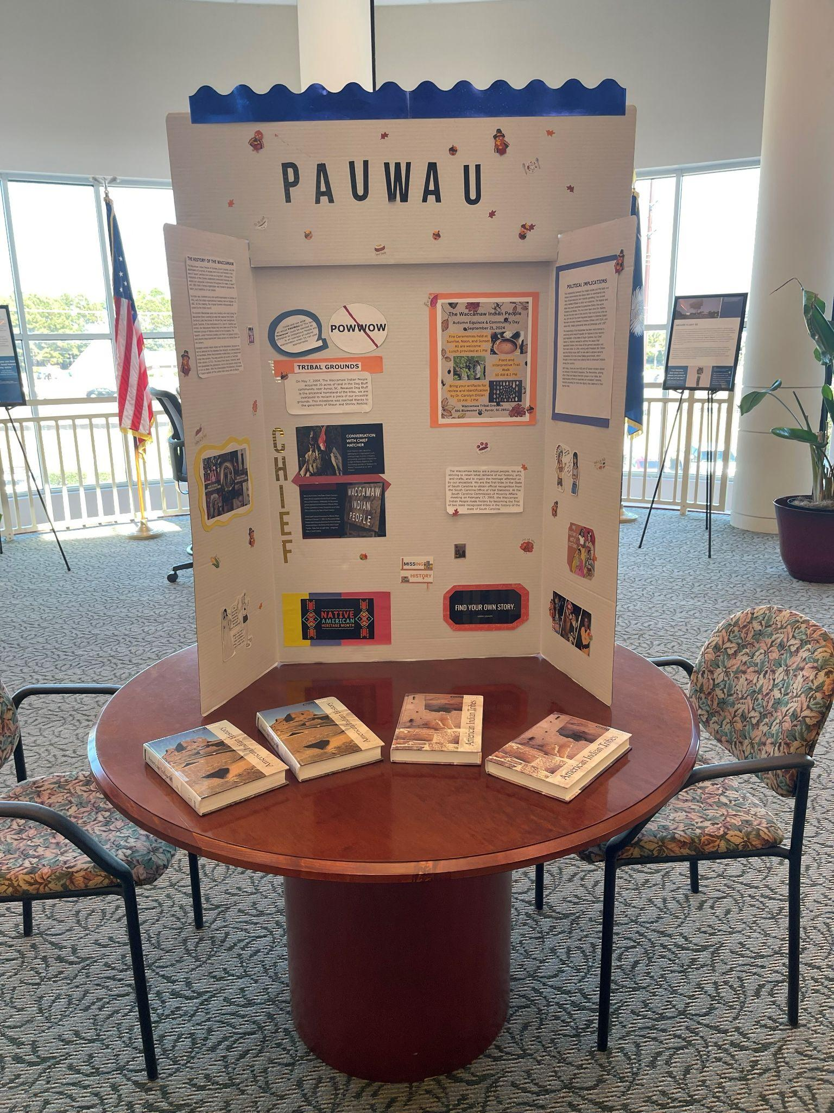

Attachment 2:

Forms response chart. Question title: Have you ever attended one of their Pauwaus?
. Number of responses: 200 responses.

Attachment 1: